**Developer details**

**Ajay Augustine**

*Github* **:** [**git-intel**](https://github.com/git-intel?tab=projects)

**GitHub Links**

* *Project:*

[**Java-LockedMe**](https://github.com/users/git-intel/projects/4)

*Linked repositories:*

[**Java_LockedMe_Repo**](https://github.com/git-intel/Java_LockedMe_Repo)

**Core concepts**

1. Exception handling in java
2. File handling in java
3. Java User Input and Scanner Class

**Sprint Plan**





**Output Screens**

1. List Files in directory

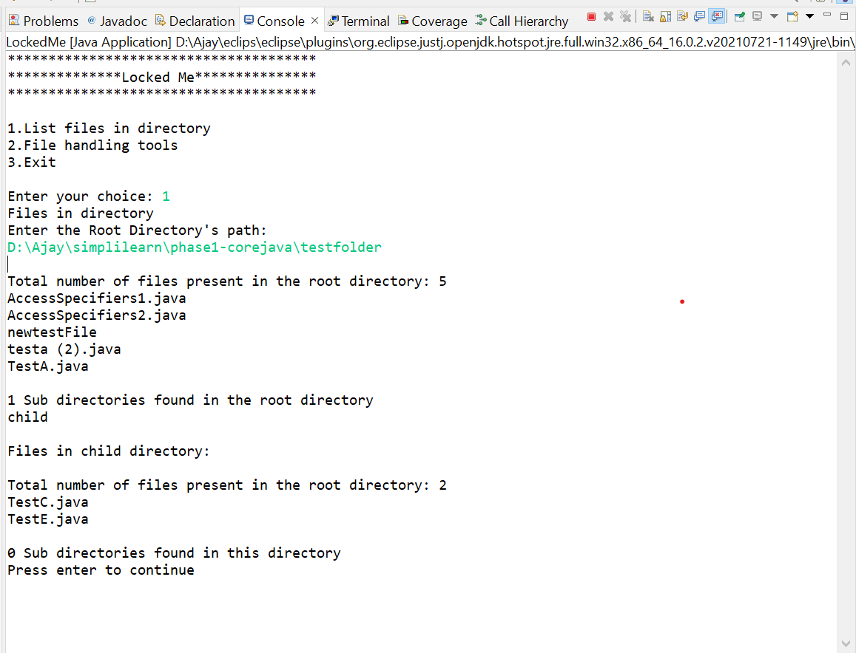

1. Add file to existing directory list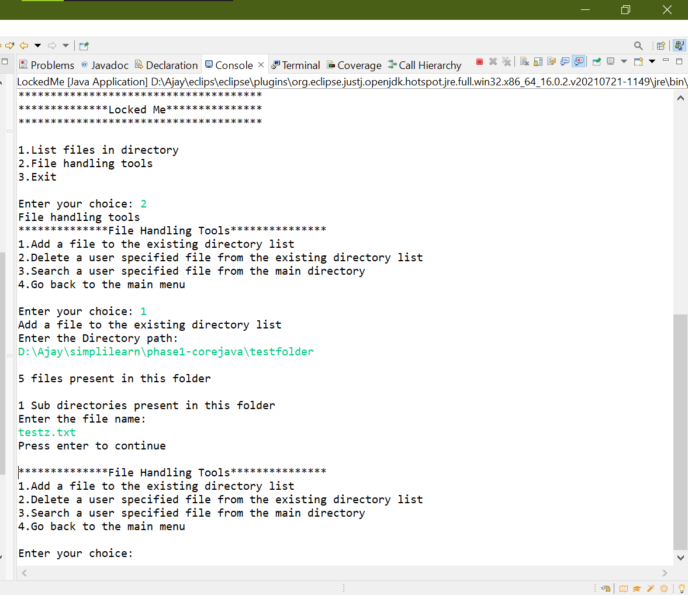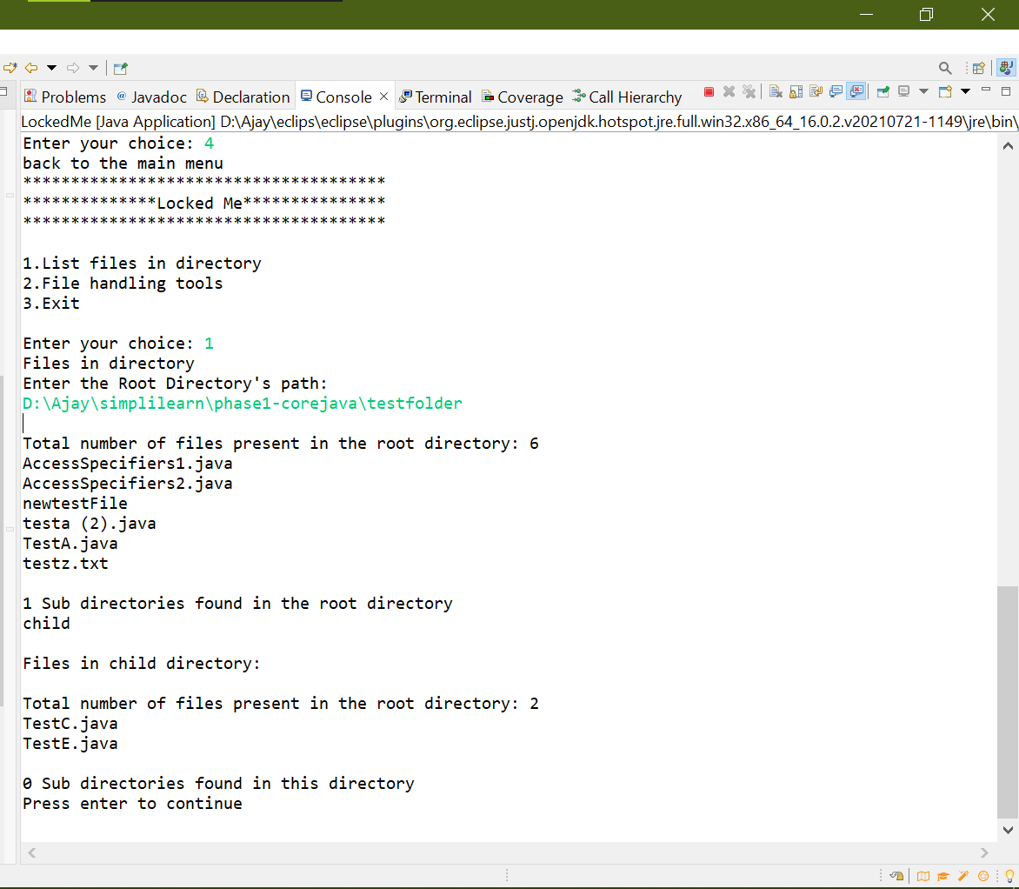
2. Delete a user specified file from the existing directory list

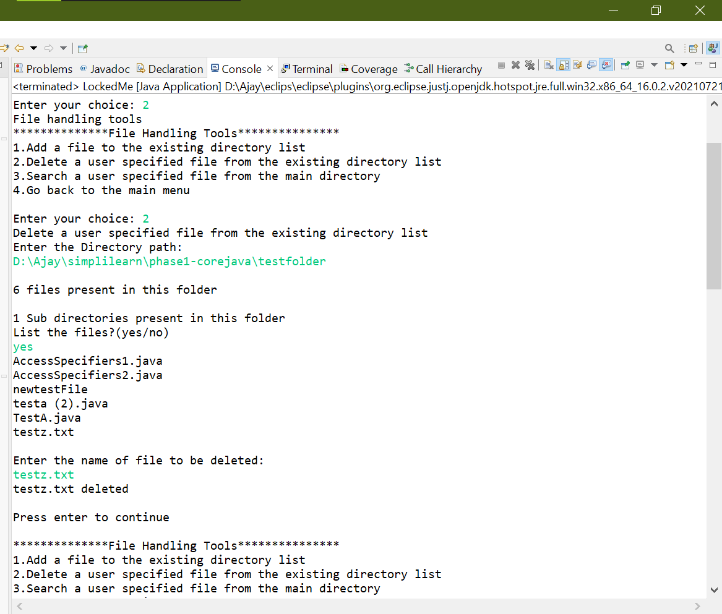

1. Search a user specified file from the main directory.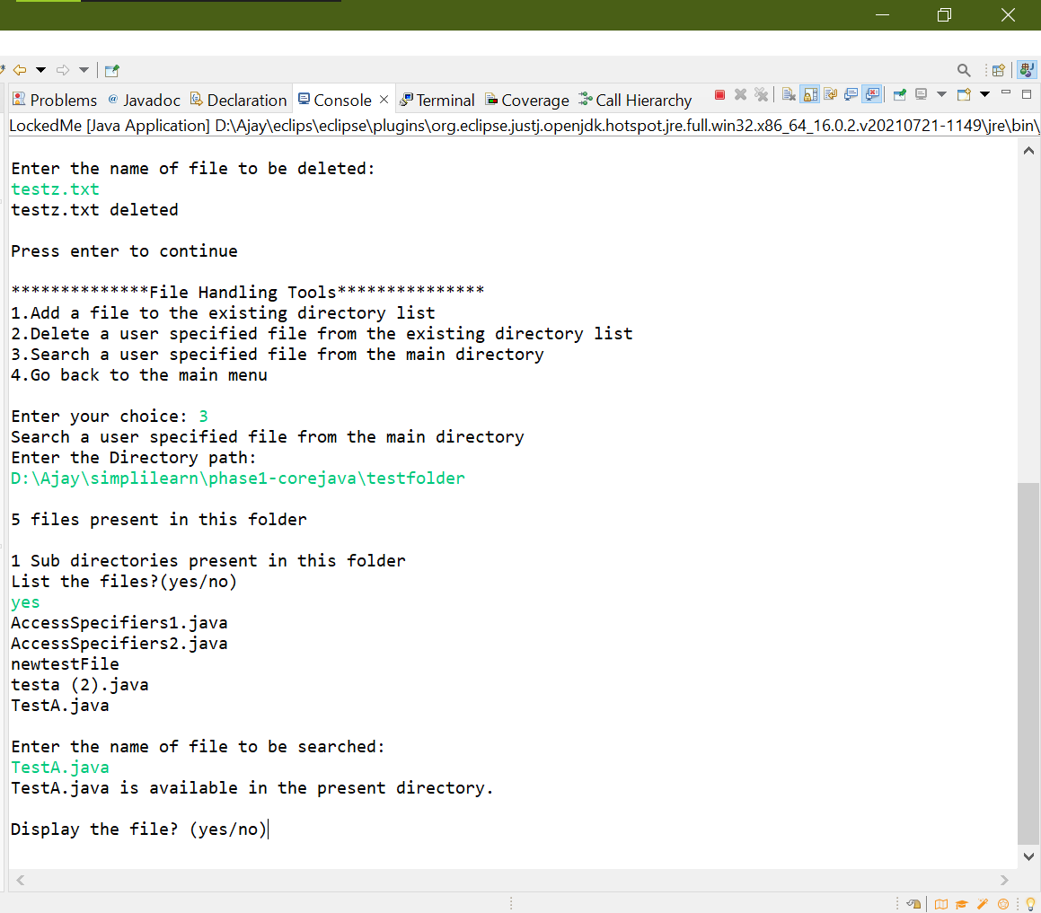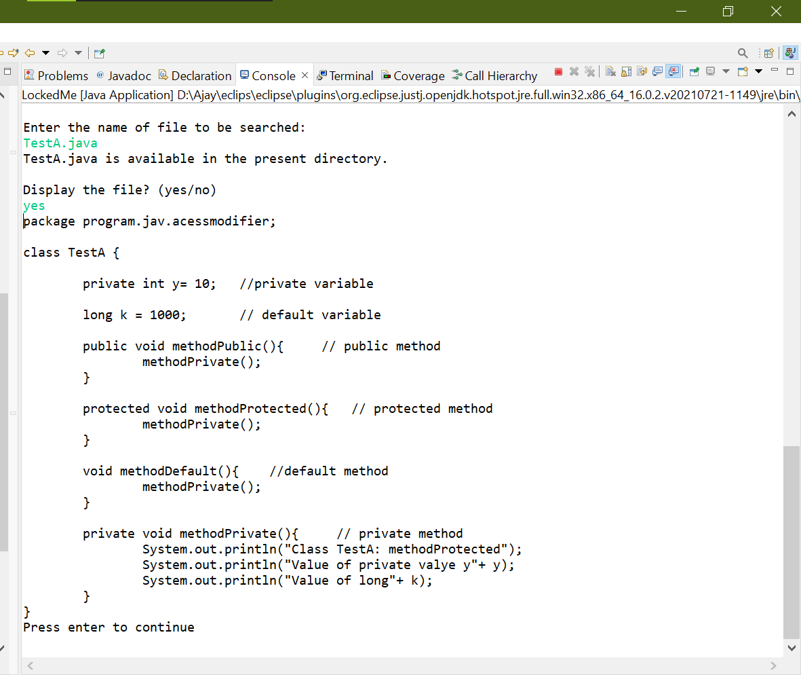
2. Exit LockedMe

